Microsoft Copilot Studio

To keep this short & simple, you want to build a copilot on Microsoft Copilot Studio. We want to provide you with access to do so. We all need to learn what it is really going to take to

a) make your copilot business case successful and

b) do it in a way that keeps the platform secure & scalable for the company.

# What we want you to acknowledge

* The internal pricing, we share with you today may be adjusted each fiscal year.
  1. Our goal is to understand the key components of the service and associated costs overall. You can help by supplying the best usage forecast you can & being as self-sufficient as possible when using the platform (e.g., minimizing the number of technical tickets you need to escalate).
* IT technical platform support will be offered live Monday-Friday 9a-5p EST.
  1. This is a best effort service to cover core platform issues, any problems related to the copilot design will be under your responsibility.

# What you can use Copilot Studio for

1. Internal facing copilots with Web widget or Microsoft Teams user interfaces
2. Data up to and including Highly Restricted sensitivity

# On the flip side, what you cannot do with Copilot Studio today

1. Consumer facing copilots. Copilots with Facebook, Slack, SMS or other social media channels.

# What you are responsible for

1. Registering any new copilot creation (see registration steps further in this document)
2. Complying with CONTOSO Generative AI policy (see additional responsibilities for Copilot owners when using Generative AI)
3. Suppling a valid cost center & agreeing to the charges (also detailed in the registration steps)
   1. You will be charged $100USD via RUS0001 every month your bot is active.
4. Developing & supporting your copilot content
   1. We strongly recommend you learn to do this yourself – the platform is well suited to this. Microsoft provides self-paced web training. The Automation COE will provide regular training & office hours.
   2. If in the case you have no capacity, the Automation COE can recommend vendors who have the expertise
5. Escalating technical platform related issues to IT (also detailed later in this document)

# Still interested? Okay, here are the costs

1. The base cost is $100 per month per copilot. This covers licensing & platform support.
2. If your Copilot exceeds 12,500 or more messages per month over a 6 month period, you will be charged $200 per 25,000 messages.

What counts as a message?

| **Copilot Studio feature** | **Billing rate** |
| --- | --- |
| Classic answer | 1 message |
| Generative answer | 2 messages |
| Agent action | 5 messages |
| Tenant graph grounding for messages | 10 messages |
| Agent flow actions *per 100 actions* | 13 messages |

This includes Microsoft Copilot Studio Licensing for developers & users, access to training to learn how to build your copilot & make it successful, access to escalate technical platform issues to our IT team (who will have access to escalate issues further to Microsoft if necessary).

# How to obtain access to copilot studio

Raise access requests in [IT Requests platform](https://alink.com):

* 1. Go to Manage User Access   
     A screenshot of a login screen

     AI-generated content may be incorrect.



* 1. Search and select the users you want to have collaborator access to build & maintain the copilot content



* 1. Once users were selected, click Next and now search for **Power Virtual Agent**  
       
     A screenshot of a computer

     AI-generated content may be incorrect.  
       
     *\* If the system throws* ***an error*** *is because the users already have the Power Virtual Agent license so is not necessary request the access for those users again*

Review and **submit** the request

# How to create & register a new copilot

If you wish to use the following features of Copilot Studio: Generative Answers, Generative Actions, Premium Connectors. Please follow the additional steps in the section labelled “Advanced Copilot Creation”

Alll Copilots must be registered in the “Copilot Registration” form in the [Copilot Studio Teams Channel](https://alink.com) (Click on “**New Item**”) and supply the following details:

* 1. A copilot name
  2. The name of the person who will own the copilot
  3. The name of a second person who will act as co-owner & backup for the copilot.
  4. A valid Cost Center so that we can recover the copilot costs
  5. The CONTOSO/GBS organization owning the copilot
  6. An estimate of how many users will talk to the copilot in an average month
  7. The data classification of the content of the copilot
  8. A list of anyone else you would like to grant collaborator access to build & maintain the copilot content (by default the owner will also be granted access)

# Advanced copilot creation (Generative AI & Premium Connectors)

At this time, while the base Copilot Studio platform is ContosoGoved (meaning individual Copilots do not need to register as applications & complete their ContosoGovRisk) – this does not extend to the Generative AI features such as Generative Answers, Generative Actions. Therefore additional steps are required before you can access these features. Failure to follow the steps and creating a Copilot in the default PVA or Personal Productivity environments & using GenAI will result in your Copilot being disabled.

To gain access to generative answers, generative actions or to utilize premium connectors (e.g. SAP, SQL, SerivceNow, Jira etc..)

1. You must have access to an existing custom Power Platform environment. If your organization does not already a custom environment, please request one: <https://alink.com>
   1. Note: The pre-requisite to requesting a custom environment is having an IT Application registered & ContosoGovRisk initiated: <https://alink.com>
2. You will also need to request approval from the Project Contoso AI team for any use case involving Generative AI (Answers or Actions).
   1. Contact Bob & Sam via email to request approval
   2. Send proof of approval to Steve

# Additional responsibilities for Copilot owners when using Generative AI features

As Copilot Owner it is your responsibility to be aware & react to the evolving landscape of rules around Generative AI usage at CONTOSO. <https://alink.com>

1. All Copilots must utilize the “Authenticate with Microsoft” or “Authenticate manually – with Azure AD2” option
2. All Copilots must display a greeting message that incudes “Just so you are aware, I sometimes use AI to answer your questions. To review CONTOSO AI policy please visit <https://alink.com>
3. All Copilot Owners & Co-owners must continually review the built in Activity Monitor & Analytics for any errors or negative feedback on generated answers or actions.
4. Copilot Owners & Co-owners are responsible for adjusting their Copilots in reaction to any guardrails for AI security & governance we implement at the platform level.
   1. We will provide at least 1 month warning via MS Teams & Email before new guardrail implementation, though that timeframe could be shortened if a critical issue is identified.

# How to escalate technical platform issues to IT (& Microsoft)

1. Raise an incident - <https://alink.com>
2. Raise a generic request – <https://alink.com>
3. If you need to escalate via email, please ensure a ticket is created first. Emails should be directed to : admin@contoso.com
4. If you need to manually raise a ServiceNow ticket, please use the following details:
   1. Configuration Item – Power Virtual Agents
   2. Service Offering - Intelligent Automation
   3. Business service - IT - Smart Automation Platform
   4. Assignment Group - CONTOSO_IT_PVA_Copilots

# Add a copilot to Microsoft Teams

Once you're satisfied with your copilot's content and quality, you can publish your copilot to allow users to engage with your copilot. Each time you want to update your copilot, you publish it again from within the Copilot Studio app itself.

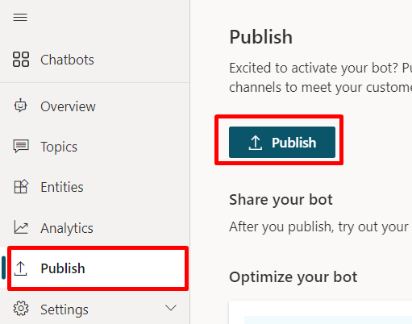

Now that you have published your copilot, you can make your copilot available to users in Microsoft Teams so you, your teammates, and the broader organization can interact with it.

**Connect to Microsoft Teams:**

1. In the navigation menu under **Settings**, select **Channels**.
2. Select **Microsoft Teams**.

* Select **Turn on Teams**.

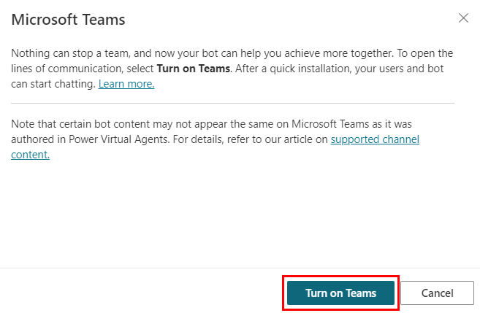

### **Show the copilot in Microsoft Teams app store to the organization**

* Select **Availability options**.
* Select **Show to everyone in my org**.

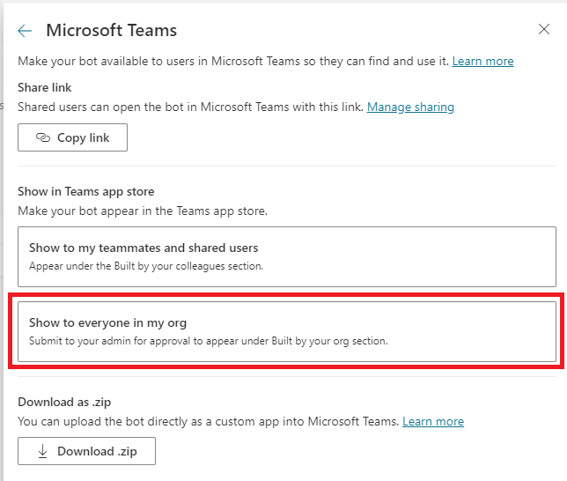

### Download the copilot's Teams app manifest - Select **Download .zip**.

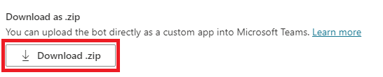

* create a Service-now ticket - <https://alink.com>

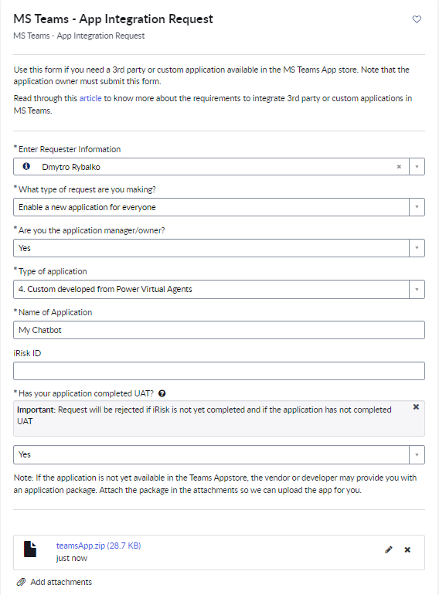

Attach a .zip Teams app manifest you downloaded in previous step.

Find more detailed instruction in [MS documentation](https://alink.com)

# Add a Copilot to SharePoint site

**!Important: Chatbot authentication type must be NOT “Authenticate with Microsoft”**

## Add bot and SP site to a registration list

Go to the [registration list](https://alink.com) and add a new item to it.

To find required information, go to your chatbot and navigate to Settings -> Advanced -> Metadata.  
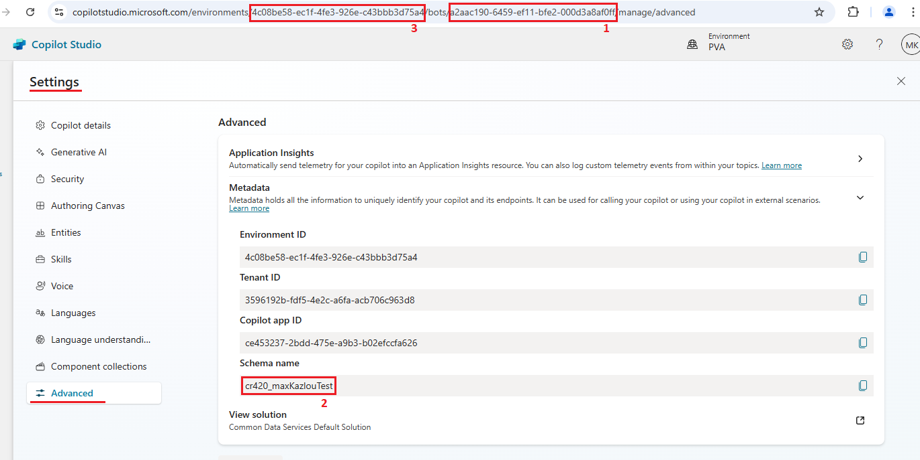



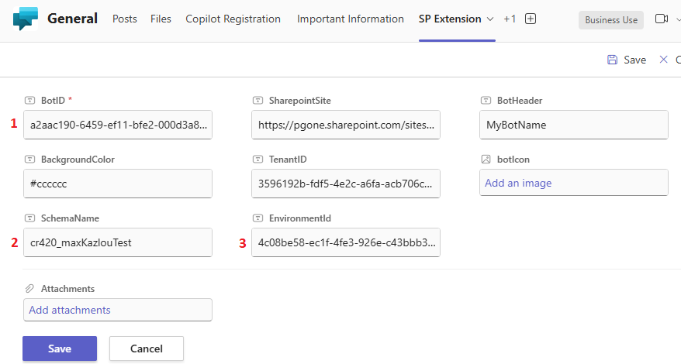



## Add connector app to the SharePoint site

1. Go to your SharePoint site, click gear icon in top right corner and select “Add an App”:

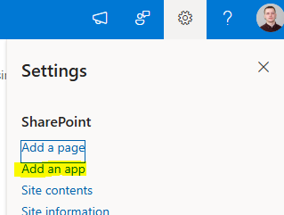

1. Search by “Copilot” word and add “**Contoso-Site-CopilotWidget**” to your site:

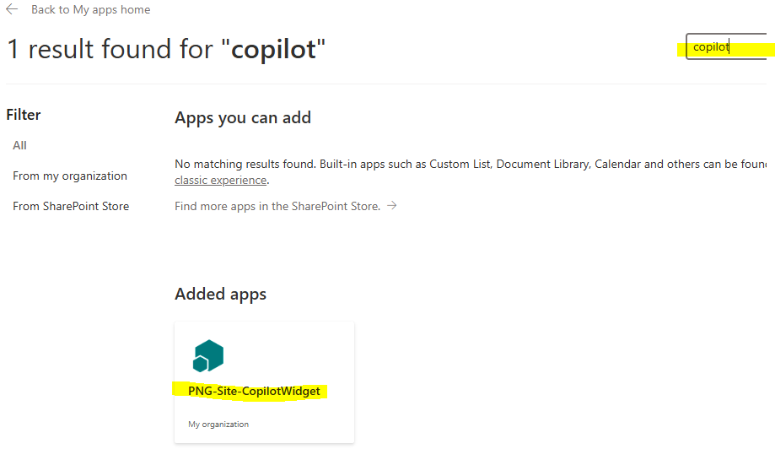



1. Enjoy!

